Timing is everything!

Plants and animals go through many important life stages in a year. For example, a bird may have babies in spring and fly south in winter. Plants may grow fruit in summer and lose their leaves in fall. Phenology is the study of the timing of seasonal life stages (phenophases) in plants and animals. In other words, its studying plants and animals and observing what they do and when they do it!

The timing of seasonal changes matters. What would happen if you went swimming and had a picnic in December? Or if a brown bear went looking for berries instead of hibernating? For many living things, timing is key to survival!

How do animals and plants know when to do what? After all, they don’t have calendars! Instead, they respond to their changing environment. Seasonal changes in weather, such as temperature, sunlight, and precipitation (rain or snowfall), signal many plants and animals to enter new phases of their lives. These changes might tell a bird when to migrate (move from one region to another) or a plant when to flower. For example, many plants grow leaves and flowers as temperatures warm, and hours of daylight increase in the spring. As the weather cools and hours of daylight decrease in the fall, many plants lose their leaves and go dormant.
How does a tree know when to lose its leaves for winter?
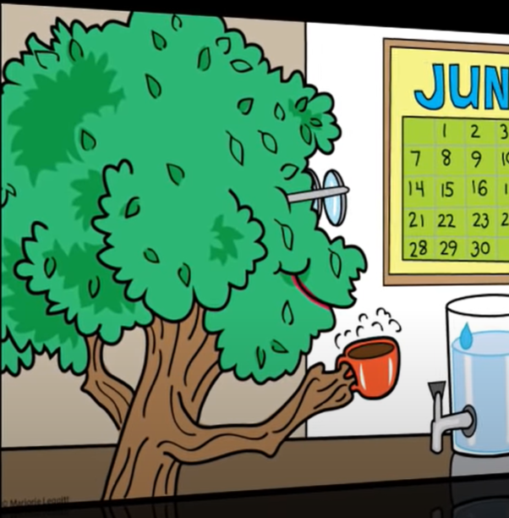

Reflection Questions: Timing is everything!

- Define phenology in your own words.

- How do animals and plants “know” it is time to go through seasonal change? (Circle all that apply)

        - Changes in precipitation (rain or snow)
        - Changes in the amount of daylight
        - Changes in temperature
        - They can look at their calendars
        - They see people wearing coats

- Brainstorm: Give one reason seasonal change is important for living things (Make a claim). Why do you say this? (Provide evidence/reasoning)

